FACULTY EVALUATION
Programme Name: Social Entrepreneurship Program (SEP)- START MASTERCLASS Uganda (26th January 2026 - 30th January 2026)
Session: Reflection and leadership and teams (employees)
Faculty Name: Lena Gachoki
No. of Respondents: 17
No. of Participants: 17
Evaluation Parameter | (%) Individual Score | (%) Programme Average
Punctuality (Commencement and Completion of Sessions) | 89 | 88
How well do you understand the core concepts presented? | 85 | 83
Rate your confidence in applying the new skills learnt | 84 | 78
Degree of Faculty preparedness for the sessions | 95 | 91
Content and methodology of the program | 91 | 87
Quality of class and group discussions | 84 | 82
The information presented in the course is relevant to my work (ministry) | 94 | 91
Average scores | 89 | 86

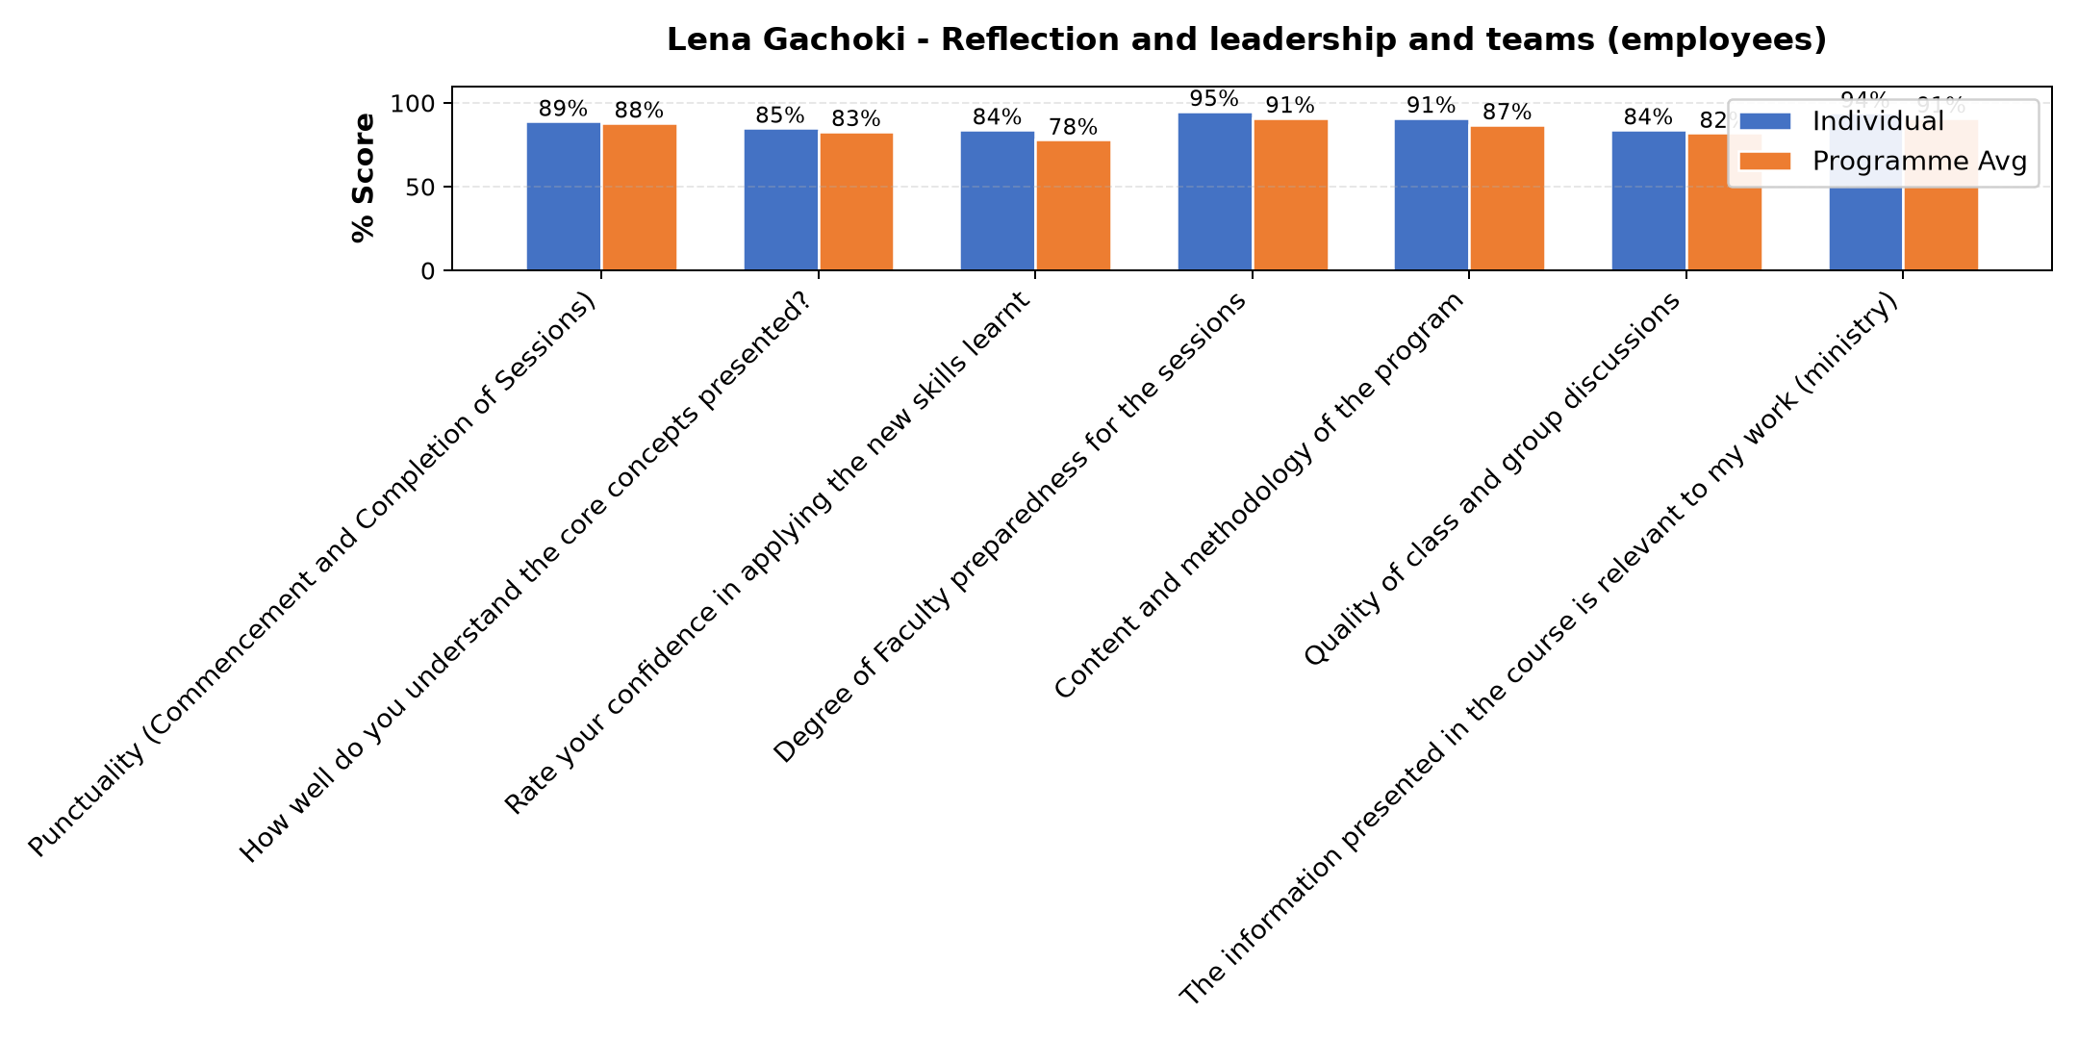

Comments & Feedback
- • Distance of the project
- • Distance
- • I think there are no obstacles to applying what I have learned in this presentation.
- • Lack of self review
- • I went back for further students , I could not fully practice my leadership skills as well as our social Enterprise is concerned.
- • Fear to take risk
- • Maybe just personal weaknesses which I have to work on
- • Lack of confidence
- • I went back for further studies
SUBMITTED THROUGH:
SBS Evaluation Automation System

